

Practices for Secure Software Report

Table of Contents
Document Revision History 3
Client 3
Instructions 3
Developer 4
1. Algorithm Cipher 4
2. Certificate Generation 4
3. Deploy Cipher 4
4. Secure Communications 4
5. Secondary Testing 4
6. Functional Testing 4
7. Summary 4
8. Industry Standard Best Practices 4

Document Revision History

Version | Date | Author | Comments
1.0 | 12/10/2025 | Abdurahim Kalonov

Client



Instructions

Submit this completed practices for secure software report. Replace the bracketed text with the relevant information. You must document your process for writing secure communications and refactoring code that complies with software security testing protocols.

- Respond to the steps outlined below and include your findings.
- Respond using your own words. You may also choose to include images or supporting materials. If you include them, make certain to insert them in all the relevant locations in the document.
- Refer to the Project Two Guidelines and Rubric for more detailed instructions about each section of the template.

Developer
Abdurahim Kalonov

Algorithm Cipher

At Artemis Financial, I introduced SHA-256 - a secure hashing method - for verifying data accuracy. This algorithm belongs to the SHA-2 group; it turns input into a constant 32-byte output. Since reversing the process isn't possible, source information stays protected. That trait supports reliable validation processes.

A hash method such as SHA-256 accepts input of any size but always gives back an output of set length. Changing just one bit in the data leads - due to the avalanche phenomenon - to a totally altered result. This "256" stands for how many bits are in that outcome; because there's so much variety among potential outputs, trying every option or finding matches becomes unfeasible using today’s tools.

SHA-256 doesn’t involve encryption keys, yet it’s typically paired with random inputs - like nonces or salts - and merged with symmetric or asymmetric methods in full security setups. Instead of one shared secret, systems may apply AES, where encryption and decryption rely on identical keys, offering speed for big data flows. Public-key schemes such as RSA or elliptic curve crypto depend on two related keys - one public, one private - often handling secure key sharing or verifying digital signatures. Within this work, SHA-256 serves only hash generation and integrity checks, whereas SSL/TLS uses public-key techniques to manage certificates and negotiate session keys.

Earlier, less secure hash methods like MD5 and SHA-1 saw broad use; however, today they’re viewed as compromised because real-world collision attacks exist. Newer platforms now rely on more robust options - SHA-256 along with SHA-3 being prime examples. While SHA-3 offers newer design principles, SHA-256 remains highly popular across sectors due to proven reliability. It serves roles in HTTPS security, digital signing processes, also blockchain frameworks. Given its widespread acceptance and strong resistance to known threats, SHA-256 fits well for Artemis Financial’s requirements around data integrity checks.

Certificate Generation
To enable safe HTTPS connections, I made a self-signed SSL cert through Java’s keytool. Created with CN: Abdurahim Kalonov - alongside O: Artemis and OU: SNHU - the cert holds both public details and encryption keys. These components are saved inside a PKCS12 container called keystore.p12. That file was moved into src/main/resources, letting Spring Boot access it once the app starts.

Once the keystore was created, the public certificate got saved as a .cer file. Since the CER is available, it means the keys can be shared and set up wherever required on user devices. To prove this step worked, there's a snapshot of the CER inside the folder structure added here - showing everything ran without issues.
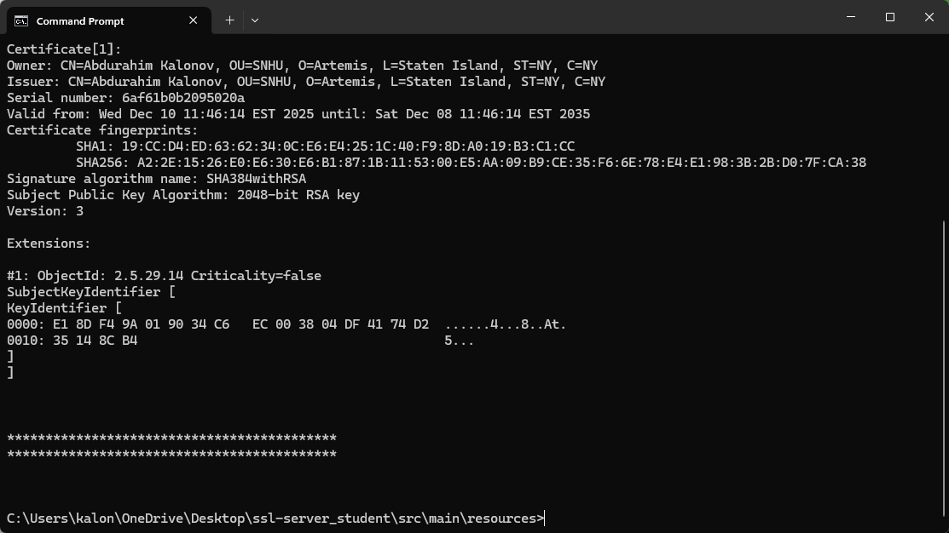

Deploy Cipher
To set up the hash function, I adjusted the app by introducing a fresh REST route under /hash. In the SslServerApplication file, code was added leveraging Java's MessageDigest together with SHA-256. This route receives a preset text containing my name along with details on the Artemis Financial checksum, transforms it into byte format via UTF-8 encoding, then runs the SHA-256 hashing process. Afterwards, the output - initially in bytes - is turned into a hex-based string representation.

The /hash endpoint shows the initial input alongside its SHA-256 hash value. Upon visiting https://localhost:8443/hash through a browser, the result appeared with both the test phrase and matching digest - this confirms the algorithm works as intended. The report contains a snapshot of that screen, featuring my name plus the specific character sequence, serving as proof the hashing process ran accurately.
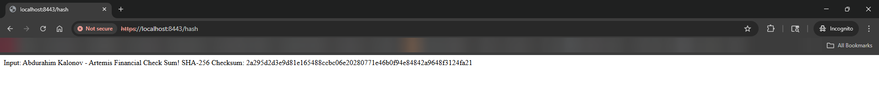

Secure Communications
To switch the app from HTTP to HTTPS, I adjusted the application.properties file so SSL could work with a created keystore. Instead, I changed the server port to 8443 while turning on secure connections. Also, I pointed to the keystore through the classpath path. Because of this setup, Spring Boot prepared an internal Tomcat instance by itself. However, it started watching for encrypted requests on 8443 only after settings were applied. Yet, each key detail like password, entry name, or format (PKCS12) had been clearly defined beforehand.

Once the app was rebuilt and launched, I went to https://localhost:8443/hash using a browser. The site appeared without issues via HTTPS, showing both the padlock symbol and cert details. When I checked inside the certificate window, it showed Abdurahim Kalonov as owner, issued under Artemis authority. It also confirmed use of SHA-256 combined with RSA encryption. That setup helps ensure trust during future verification phases.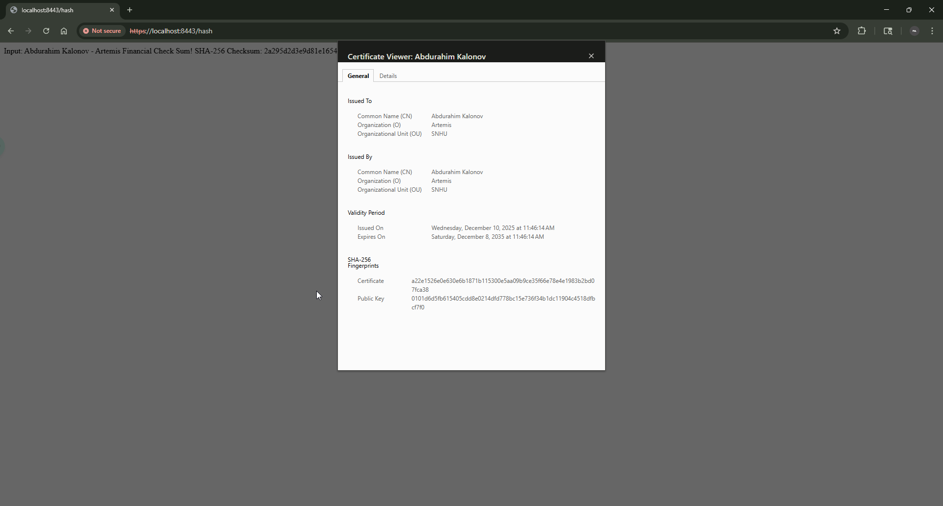

Secondary Testing
To make sure my updates didn't create security risks, I used a secondary static vulnerability analysis with the OWASP Dependency-Check Maven tool - inserting its setup into pom.xml then triggering the mvn verify step. This tool scanned every external library the app relies on, comparing them to publicly listed flaws.

The generated HTML report revealed several flaws in current external libraries like Spring Boot, Jackson, or similar tools. Since these issues stem from the initial code structure, they’re unrelated to the newly introduced checksum and SSL components I implemented - instead linked to older assets. Still, they point toward the importance of updating library versions regularly while scheduling fixes ahead of time. One image displays the IntelliJ output where dependency-check ran successfully with no compilation problems; another captures the detailed findings inside the HTML summary - all attached here to support later validation steps.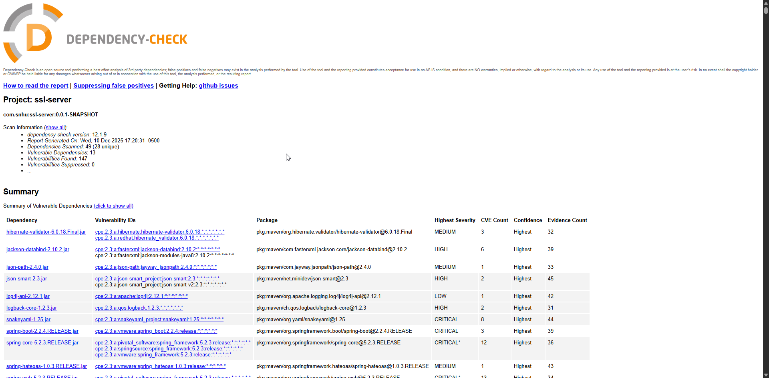

Functional Testing
Alongside static checks, I tested functionality through manual functional and security code review and execution of the app. Using IntelliJ IDEA, I launched the Spring Boot setup while observing console messages to spot any coding or execution problems. Output confirmed smooth startup - no errors appeared during launch. The log entries indicated Tomcat booted up correctly on port 8443 using HTTPS, alongside a successful load of the application environment.

I accessed the /hash endpoint through a browser using HTTPS and checked it by hand. It gave back the right SHA-256 hash for a set test string - proof the updated code works properly. Instead of just assuming it was secure, I looked over the source closely, searching for risks like unintended data leaks or visible internal structure; however, no private info was exposed via hashing. As support, there's a picture showing the revised code running smoothly in IntelliJ, meaning tests passed without problems.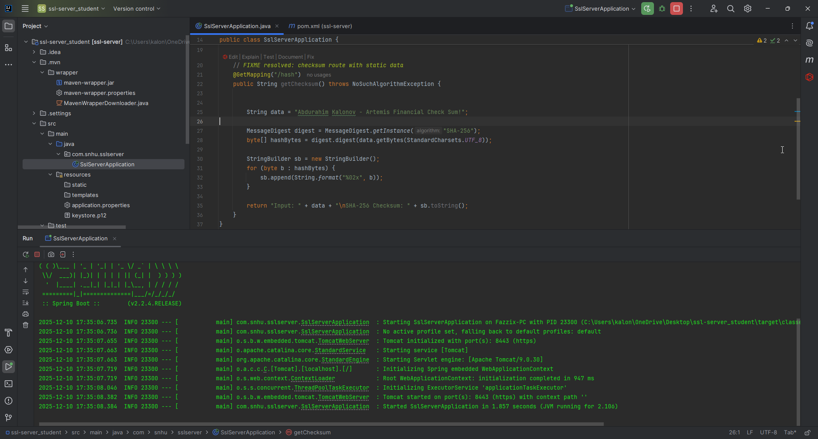

Summary

This project entailed the redevelopment of the Artemis Financial software using various security layers, following best practices for the development of secure software. Following the Vulnerability Assessment Process Flow Diagram, the project aimed at addressing various critical areas of security, which involved cryptographic mechanisms, secure communication, management of dependencies, and the reliability of the software. The project developed a checksum endpoint using SHA-256 for integrity checks, developed a self-signed SSL certificate for the implementation of HTTPS, and changed the software properties for enforcing secure communication using port 8443.

Furthermore, the OWASP Dependency-Check plugin was incorporated into the project for the purpose of monitoring vulnerabilities within third-party libraries. This will ensure that the vulnerability management and monitoring phase of the assessment is also covered. Functional testing for the refactored software showed that it works without errors, and the new security features incorporated into the system do not constitute new vulnerabilities. Overall, the improvements made will strengthen the level of confidentiality, integrity, and resistance of the software against common threats, hence improving trust for the safeguarding of sensitive financial data handled by Artemis Financial.

Industry Standard Best Practices

In this project, I used common secure coding methods. Rather than pick outdated algorithms like MD5 or SHA-1, I chose SHA-256 because it’s more reliable. To safeguard data during transfer, I set up SSL/TLS using a well-maintained keystore, ensuring HTTPS was active across all connections. Security settings - including keystore location and credentials - were moved outside the code into application.properties, making them easier to manage without hardcoding.

I included automatic checks for flaws through the OWASP Dependency-Check tool to keep track of risks in external libraries. Such monitoring follows common standards for managing software components. Using these methods improves Artemis Financial’s defense against threats, lowers chances of leaks, while supporting adherence to rules and user confidence. With security built into development workflows, protection of client data becomes more reliable - aligning with their principle that safety is a shared duty.

